CS 255 Business Requirements

System Components and Design

Purpose
- DriverPass’s purpose is to give access to driving instruction and resources, as to increase the success rate of drivers at the DMV. They want to do this by supplying practice exams and driving education resources, as well as having an on-the-road service with instructors that can be scheduled.
- The DriverPass system would allow students, instructors, and secretaries to coordinate and track process of education and driving training. It would also allow management and IT the ability to organize and update content for driving training as required by the DMV.
- The system should increase driver success rate as well as be scalable for more students to access their resources as DriverPass grows.

System Background
- DriverPass wants a system that is easy to get to from anywhere, so it should be a web application that works on a browser with some read-only material available when a student is offline.
- They are trying to fix the problem that there are many student drivers failing the DMV test, and that there isn’t a single place where students can seriously commit study time, schedule lessons, and track their progress all.
- The DriverPass system will be an online system with different user roles. Students should be able to schedule lessons and cancel lessons, take practice exams, and look at their results. Students should also be able to reset their passwords if they cannot log in. Instructors need to be able to see and manage a schedule, and instructors need to also be able to leave notes on the students that they work with. Secretaries should be able to do secretarial things, mostly just schedule lessons and change schedules as well as help with account problems. IT needs to be able to change a user’s role, needs to be able to update or change the system services and data, and also needs to able to troubleshoot the whole system. Management needs to be able to look at reports and schedules as well as being able to export these things. Management also needs to be able to manage the different user accounts.
- The system also needs to keep DMV information up to date. This is a very important aspect of DriverPass.

Objectives and Goals
- Users should be able to log into driver pass with their account, and the system should show them information depending on the role that their account is designated to.
- The User accounts should be safely doing what they should do, and they shouldn’t be able to do what other accounts can do.
- Students should be able to study material and take practice tests.
- Students should be able to schedule driving lesson appointments that don’t conflict with other students.
- Secretaries should be able to make or change appointments and help with account troubleshooting.
- Institutors should be able to pull up their schedules, see information about the student like previous notes, and they should be able to take notes on the student.
- Management should be able to make data reports that are printable and also should be able to make reports of the schedules.
  - Data reports could have to do with student attendance, pay schedules, instructor attendance, important metrics for running a business.
- IT should be able to change data on the system and update data, as well as trouble shoot the system and accounts.
- The system should automatically update when the DMV changes rules.
  - Testing information should be what the students are going to be tested on in the DMV test.
- User accounts need to be able to reset and change their own passwords securely.
- The site should look clean, see GUI diagram from DriverPass.
- The site should be responsive on whatever browser the user is on.
- The site should have some offline read-only data available.

Requirements

Nonfunctional Requirements

Performance Requirements
- DriverPass will be accessible from anywhere.
- DriverPass will be responsive.
- DriverPass will be able to handle multiple users without slowing down or barring people from logging in.
- DriverPass be able to update its data when the DMV changes or updates its rules and laws.
- DriverPass will have minimal downtime.

Platform Constraints
- DriverPass will work on Windows computers through a webpage.
- DriverPass will work on MacOS computers through a webpage.
- DriverPass will work on IOS and Android computers through a mobile browser system.
- DriverPass will be hosted and run on Linux with public access through HTTPS.
- DriverPass will need different databases:
  - SchedulingDatabase
  - UserAccountsDatabase
  - InstructorNotes
  - StudyMaterial
  - PracticeTests
  - StudentProgress
  - DataLogDatabase
- DriverPass page will be cached for faster loading, also this allows for offline information to be used, and it will be cached depending on the user’s role.
- DriverPass will be logging data information so that management and IT can see reports.
- DriverPass will need to be backed up regularly, probably periodically every five minutes. The system should be able to be restored easily if something goes wrong.
- Driver Pass needs encryption due to personal information use.

Accuracy and Precision
- Every user will have a unique ID in the UserDatabase.
- Every ID will be tied to a different role. Because every ID will be tied to a different user.
- Each ID only has access to what is defined within its role.
- Usernames should not be case sensitive because they are tied to an ID and case sensitive on usernames isn’t good customer service.
- Passwords are case sensitive.
- If something critically goes wrong a back up will be used to revert the system to the latest system build that was not critically wrong.
- Everything that is happening within the system is logged in the DatalogDatabase. These are logins, role changes, password changes, schedule edits, note updates, and report prints. There is always a record of what ID did any action at any time.

Adaptability

- IT will be able to add, remove, or change user accounts and their roles.
- Management will be able to add, remove, or change user accounts and their roles.
- Every action and change will be logged.
- Operating system and runtime changes should be updated on the back end so that it does not affect the user experience.
- The databases should be updated easily.
- The DMV should be able to update StudyMaterial and PracticeTests.
- IT needs to be able to change databases to troubleshoot and update information, such as the DMV material and practice tests.

Security
- To log in a user needs a valid account and a valid password.
- A valid password should be at least 12 characters, have one capital letter, one special character, and at least one number.
- All user accounts should also be encouraged to use multifactor authentication.
- Some user accounts should be required to use multifactor authentication, specifically admin and IT.
- All traffic between the browser and the server should be HTTPS secured.
- If someone fails to log into an account 5 times, then the account should be locked for review by management or IT.
- If a user needs to reset their password, they should be able to reset it themselves through an email link and a phone text validation.
- User accounts need a valid phone number.
- User accounts need a valid email.
- Any activity in the system needs to be logged into DataLog.

Functional Requirements
- The system shall validate user credentials when logging in.
- The system shall only allow users to see what their role is allowed.
- The system shall let users reset their own passwords.
- The system shall support multi-factor authentication.
- The system shall require multi-factor authentication in some cases.
- The system shall require all users to have a valid email address
- The system shall require all users to have a valid phone number
- The system shall allow secretaries the ability to schedule, change, or cancel appointments for students, and help handling scheduling conflicts.
- The system shall allow secretaries to troubleshoot customer service for password resets.
- The system shall allow students to schedule driving appointments and cancel driving appointments.
- The system shall allow students to be notified when their driving appointments are made or changed or canceled.
- They system shall allow students the ability to study DMV material and take practice tests.
- The system shall grade practice tests and show students their results.
- The system shall track student progress and instructor notes.
- The system shall allow instructors to see their schedule and their students’ information, including notes.
- The system shall allow instructors to take notes on a student.
- The system shall let management and authorized IT users export data in a readable format.
- The system shall generate reports on the data for management.
- The system shall log every action into the system.
- The system shall alert IT and management of problems.
- The system shall lock accounts after repeated failed login attempts.
- The system shall work responsively
- The system shall look good with a clean GUI across different browsers and systems.
- The system shall have a backup feature.
- The system shall be able to update or rolled back to a backup without losing system online-time.

User Interface
- The User interface needs to be role based.
- The User interface will show user information based on their role.
- The User Interface will have to handle scheduling, lesson tracking, user management, and the DMV study material and practice tests.
- The User Interface needs to give immediate feedback when a user interacts with it.
- The User Interface should include a changelog, for example DMV Updates for students, Scheduling updates for all users, and User Account updates for administrators and IT.
- The user interface will work on modern browsers for windows and macOS, it should also be able to be used on mobile browsers on iOS and Android.
- Management and IT should be able to see change logs for all activity.

Assumptions
- Users have internet access.
- Users have memory on their computer.
- I am not an accountant, and I did no accounting for billing. DriverPass business should be handling that.
- Users have modern computers.
- IT users update the DMV information if the DMV doesn’t have an API
- For offline behavior, there will only be a limited amount of read-only material. Security sensitive subjects cannot be an offline item.
- DriverPass never designated the system as a native App for the mobile systems so they will work as mobile websites for now.
- Users can use computers well enough to make their own schedules or use practice material.
- Users know how to troubleshoot their own passwords without instructions.
- Users have a cell phone.
- Users have a valid email address.
- A 12-character password is safe enough for the information stored in the system.
- The DMV has a feed where they update their rules and laws.

Limitations
- Offline is limited to read-only information until the offline version allows for offline verification.
- Any change in how the system works or looks will need to be changed through development or a developer. DriverPass will own their source code though.
- The system is dependent on the DMV providing updates, if they don’t update any of their information then the information in the DriverPass system will be outdated.
- Older browser and older operating systems will not be supported.
- If the network the user is using is slow DriverPass will also be slow.
- Depending on the User available memory DriverPass might run slow.

Gantt Chart

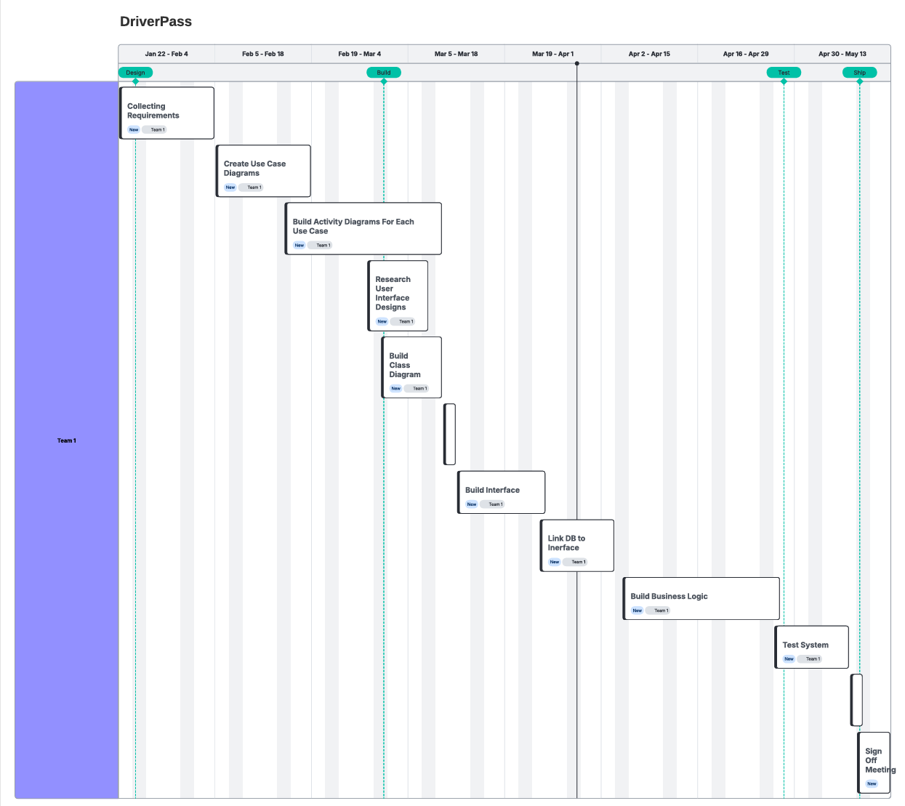

UML Diagrams
Use case Diagram
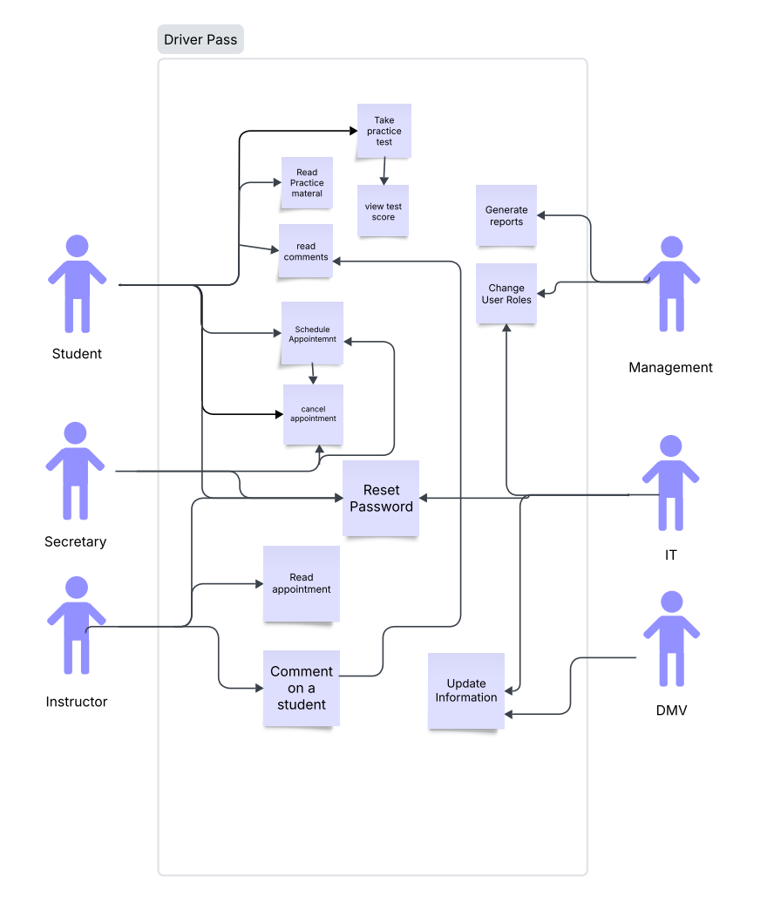

Activity Diagram:
Generate Report
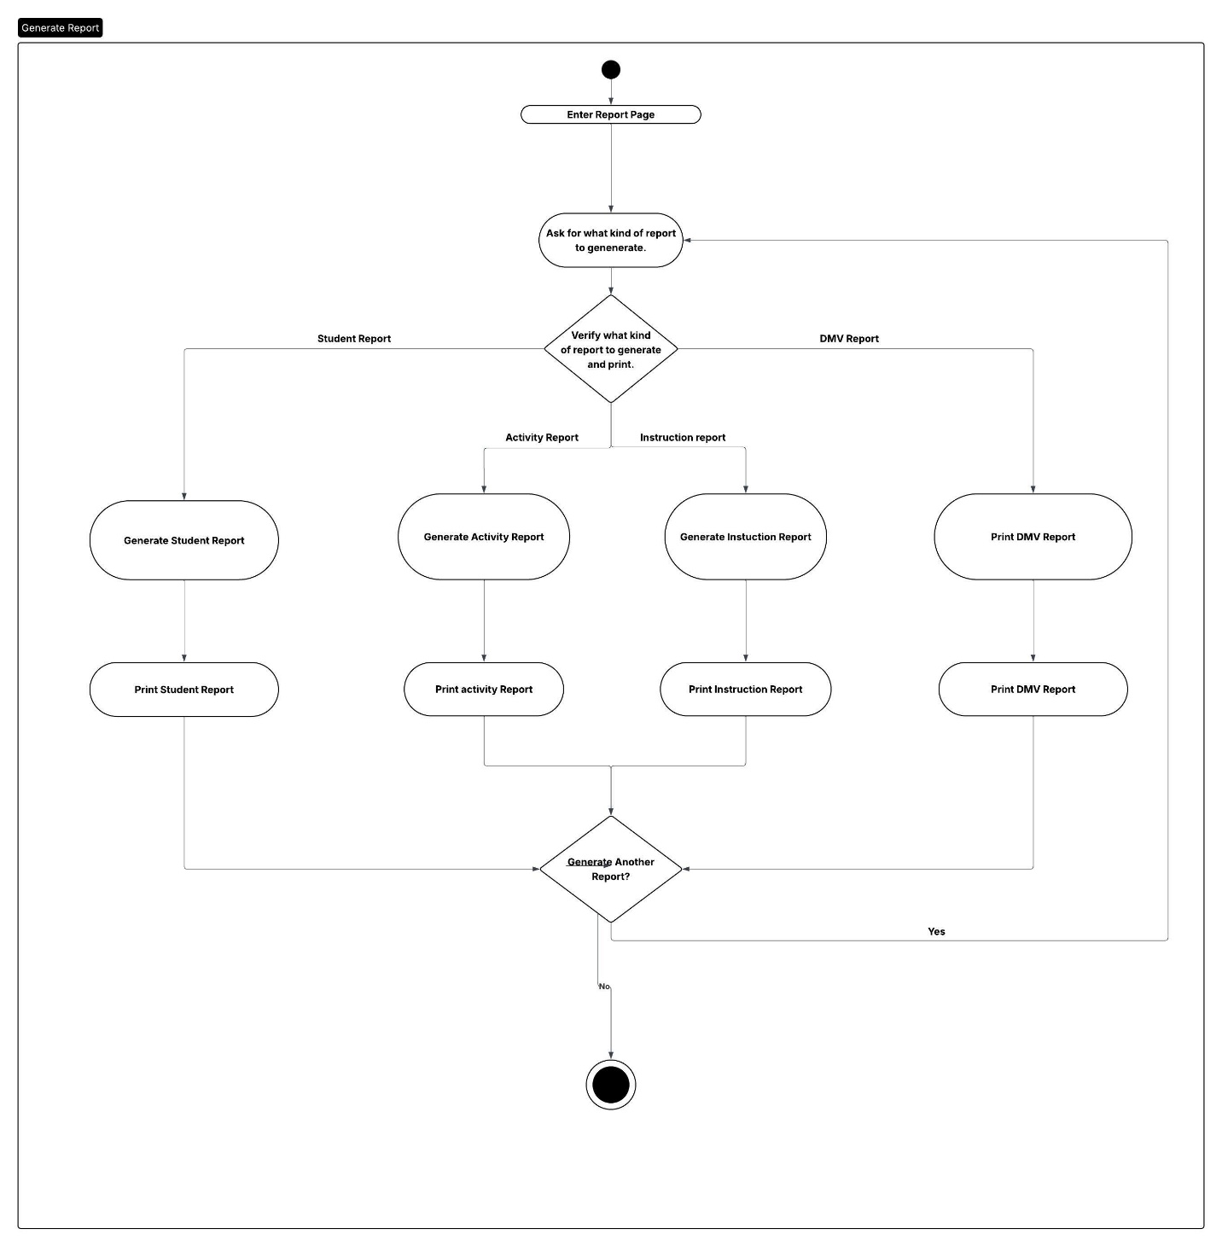

Activity Diagram:
Take Practice Test
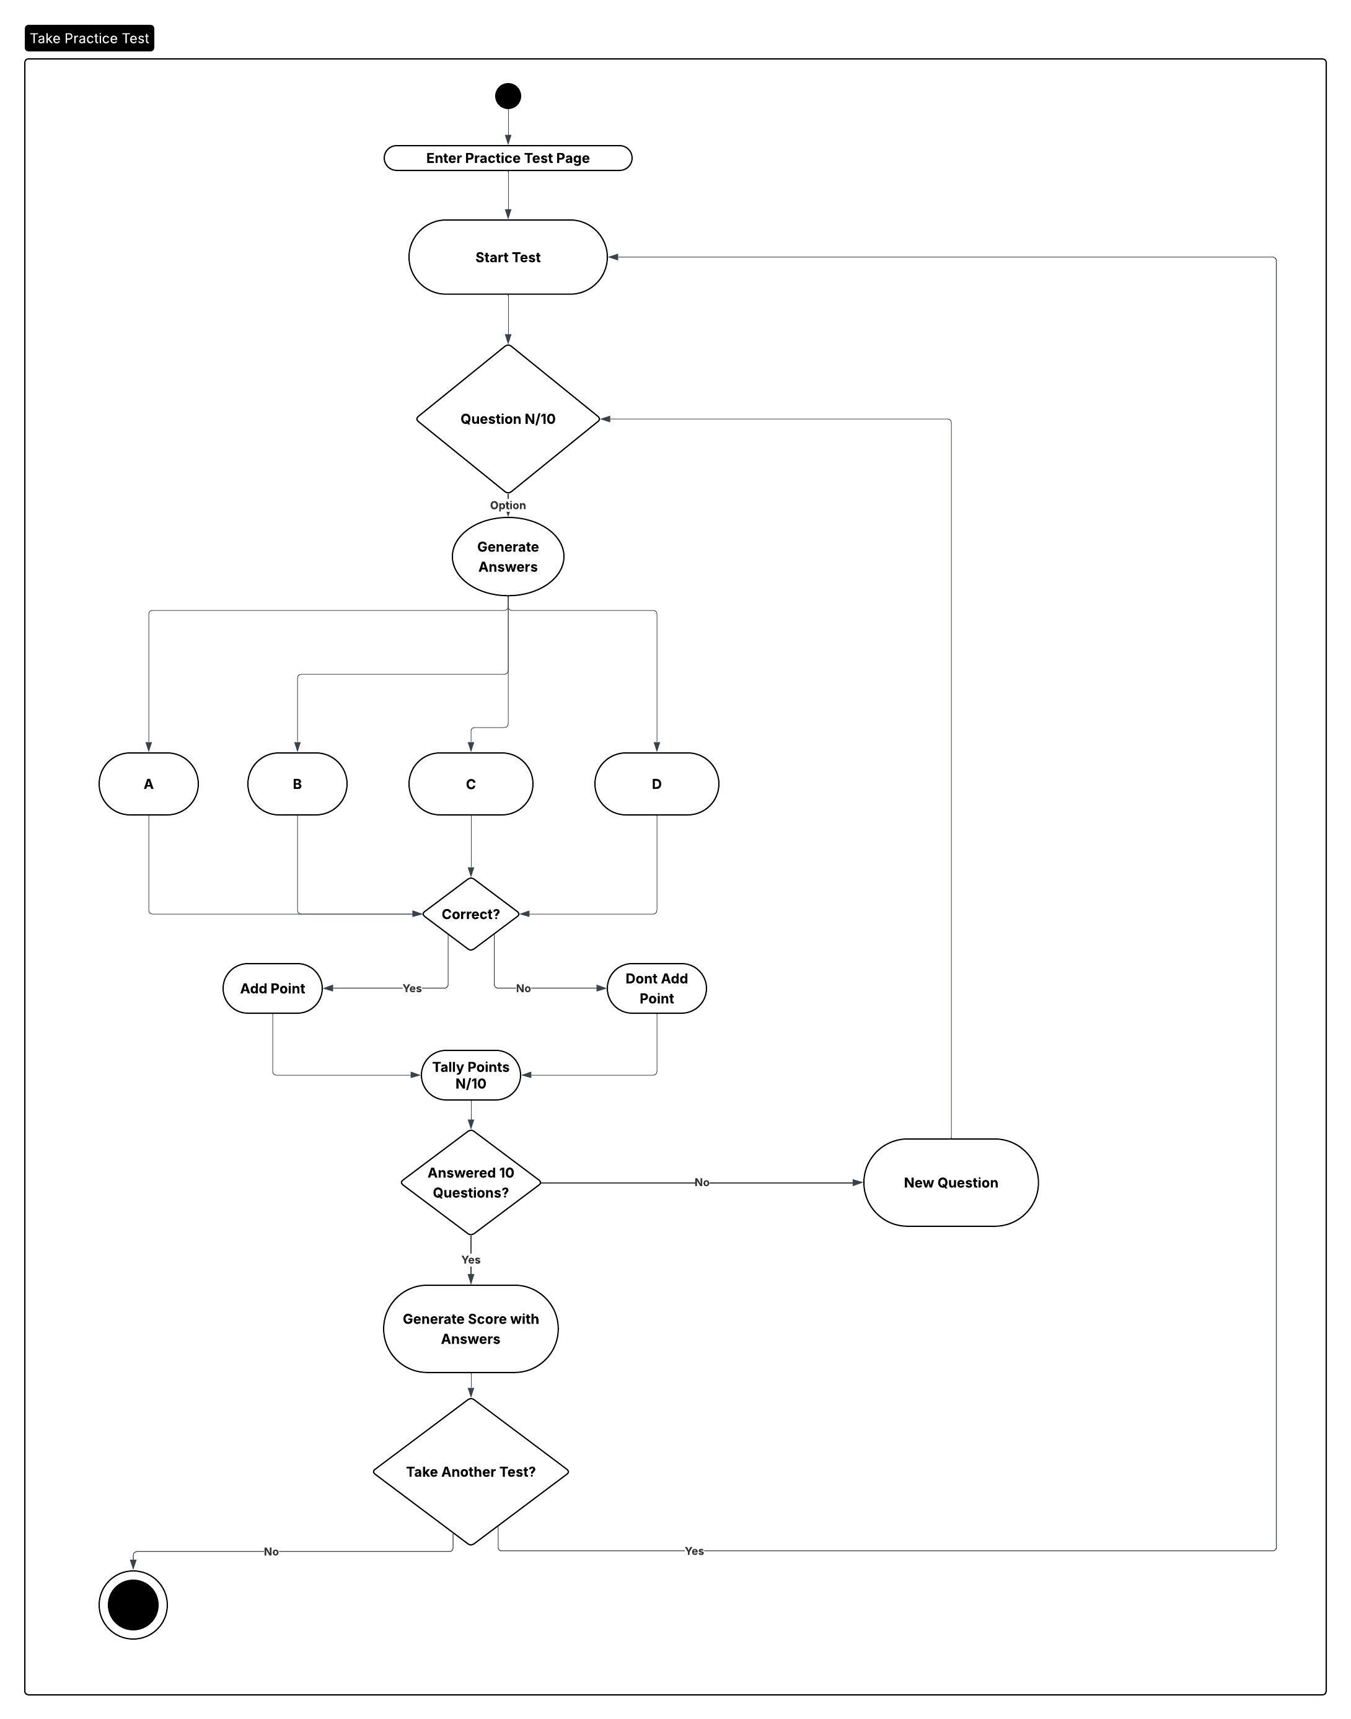

Sequence Diagram:
Generate Report
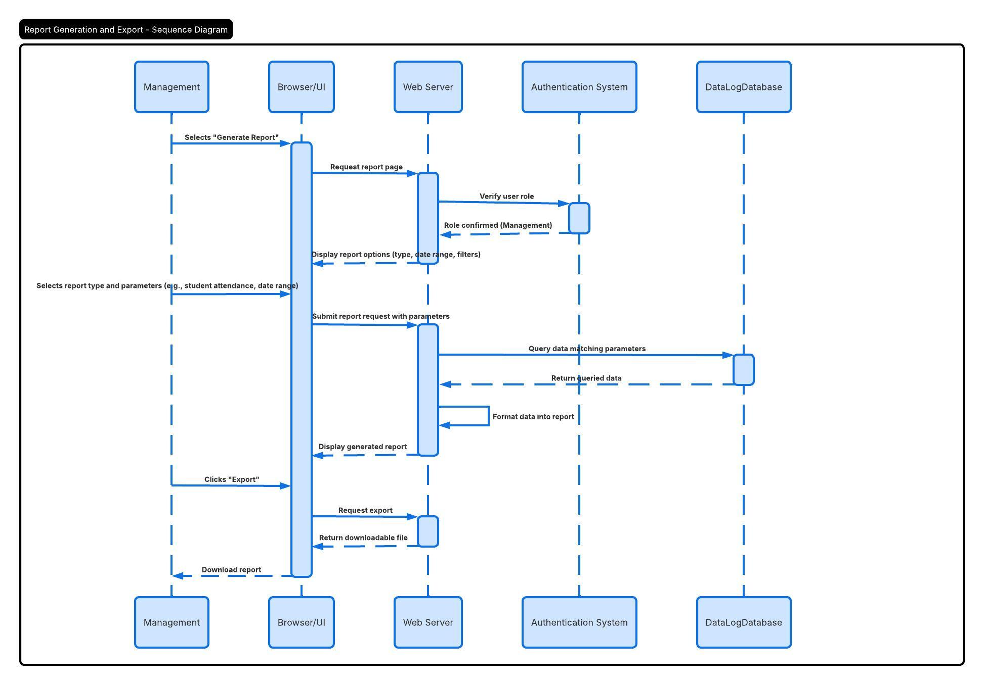

Class Diagram:
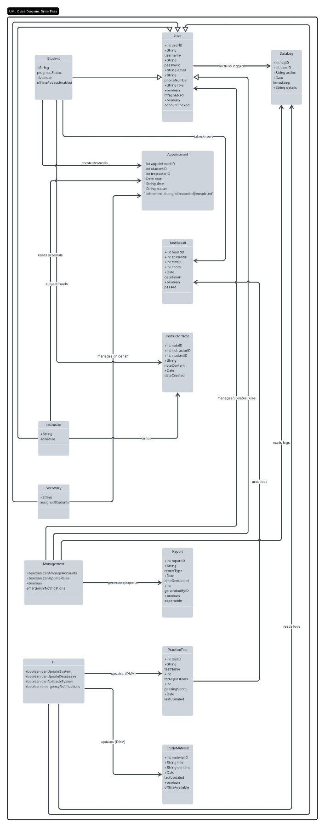

System Technical Requirements

DriverPass will be a cloud-hosted web application accessible through modern web browsers on Windows, macOS, iOS, and Android devices. The system will be built on a Linux server environment with HTTPS encryption enforced for all traffic between the client and the server.
DriverPass will require a cloud-host Linux server with sufficient processing power and memory to support multiple concurrent users without performance degradation. Storage capacity must accommodate the different databases that will be built for DriverPass. The different databases include scheduling database, user accounts database, instructor notes database, study materials database, practice tests database, student progression records database, and the dataLog database. A secondary backup server is required to periodically backup DriverPass in case a rollback must be performed.
DriverPass will be a service side application run on a linux operating system. A relational database management system will be used to manage the seven identified databases: SchedulingDatabase, UserAccountsDatabase, InstructorNotes, StudyMaterial, PracticeTests, StudentProgress, and DataLogDatabase. The front-end will be responsive web application compatible with modern versions of chrome, firefox, safari, and edge on both desktop and mobile browsers. The package used to design will be decided by what works the best and is most responsive. Browser caching will be implemented to support faster load times and limited offline read0only access to certain reports and to student study materials.
DriverPass will implement HTTPS encryption for all data used by the user. A password policy will enforce a minimum of 12 characters with at least one capital letter, one special character, and one number will be required. Multi-factor authentication will be supported for all users and required for IT and management accounts. An account lockout mechanism will trigger after five consecutive failed login attempts. Password resets will be handled through email link and phone text validation.
DriverPass will use a role based access control ionfrastructure framework to restrict user interface elements and data access based on five defined roles: Student, Instructor, Secretary, Management, and IT. All system activity: logins, role changes, password changes, schedule edits, note updates, and report generation will be logged in the DataLogDatabase. The system must integrate with the DMV’s data feed to automatically update study materials and practice tests content when rules or laws change. If the DMV cannot provide an API then IT staff will update this database manually.

